General information about the crops
Guar (kharif)

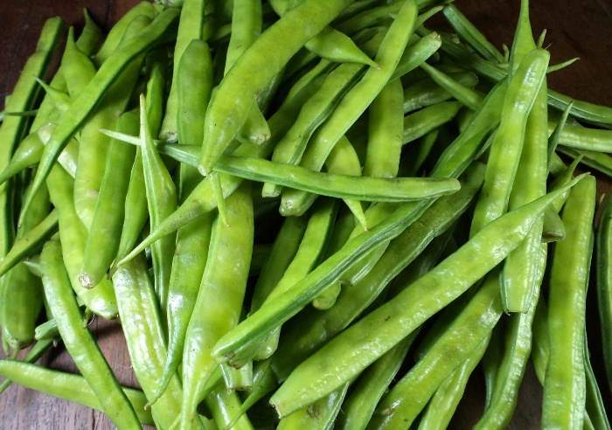

Common name- gavar, gawar, or guvar bean
GENERAL INFORMATION
Guar is an important legume crop. It is cultivated for fodder as well as for grain purpose .also it is used as vegetable and green manure. Guar gum is extracted from guar beans, has several industrial use. It is used to make gum powder which is used in oil extraction industry, food processing and preservation and printing, textile and paper industry it is use as fodder for animals.

- Climate
Temp(MIN/MAX)  (28-30) | Rainfall(MIN/MAX)  (10-11 cm)
Sowing Temperature  28-30 | Harvesting Temperature  30-35

- Popular variety with their Yield.
Variety | Yield
 | 8
  HG-365
HG-563 | 8
HG-870 | 8
HG-2-20 | 5.54
Fh277 | 15
Hfg156 | 15

- Land preparation
  - After harvesting of rabi crop one deep ploughing from mould board plough or disk harrow followed by 1-2 harrowing or ploughing and planking.
  - Properly leveled field is required for good drainage.

- Sowing- complete sowing from mid-july to mid-august
Row to Row- 45 cm (normal), 30 cm (single stem variety)
Plant to Plant- 15-20 cm

- Seed Rate - 8-10kg/acre
Treatment- To prevent crop from soil borne disease seed can be treated by 2 g Thiram and 1 g Carbendazim /kg seed. Seeds can be treated 2-3 day before sowing. After fungicide seed treatment the seed is inoculated with suitable Rhizobium culture @ 600g / 12-15 kg seed.

- Fertilizer Requirement
Condition | Urea | MOP | DAP/SSP
 | 20 | - | 120

Nutrient requirement
Condition | nitrogen | phosphorus | potash
 | 9 | 19 | -

Apply nitrogen@9kg in form of urea@20kg and phosphorus@19kg in form of SSP@120kg/acre before sowing

- Weed Control- Before germination of the crop application of Pendimethalin 0.75 kg/ha a.i. as pre emergence and for post emergence application Imazehtapyr 40g/ha a.i. in 600 litres of water is applied at 20-25 DAS is suitable for weed control. Wheel hoe and Hand Hoe is used for Inter Culture operation to reduce the expenditure. Flat Fan Nozzle should be used for spraying.

- Irrigation- For good production of the crop one irrigation can be given at the time of flowering and pod formation if crop suffers moisture stress. Cluster bean cannot tolerate water logging condition therefore proper drainage is required in the field

- Plant protection- . Sucking insect: Jassids, Aphids and While fly are sucking insect. For controlling these insect apply Imidacloprid @ 0.2 ml/liter or Dimethoate @ 1.7 ml/liter of water.
2. Termite: Termites damage plants by eating away root and stem, which cause poor plant stand.
Control Measures
i) Use well decompose FYM (Farmyard manure);
ii) Seed treatment with Chlorpyrifos @ 2 ml/kg seed;
iii) Application of Chlorpyrifos dust @ 20kg/ha at the time of last ploughing before sowing.

- Harvesting- For grain purpose crop, harvesting is done when leaves become dry and 50% pod turn brown & dry. After harvesting crop should be sun drying then threshing is done by manually or thressure. For fodder crop, crop cut when crop at flowering stage

- Storage- guar seed must be well dried before storage. Generally there is 18% moisture in seed. After harvesting seed must be spread in sunlight for 7-8 days with three time turning up and down. Storage bag must be clean and dry

